**Project Management Proposal**



**Information Science Department (IS)**

**Title: Immersive Learning through Augmented Reality for Children Quality**

**Education**

**Date: 20.2.2024** Summited by **Mg Thwin Htoo Aung (6IST-1)**

**Abstract**

This project is about an Augmented Reality (AR) application with simulated 3D models where children can study in 360°degree immersive and interactive learning experience. This application offers opportunities to revolutionize educational methodologies and improve learning outcomes, particularly for children. It is designed as a teaching aid for shaping and enhancing the quality of education. This project will introduce the concept of Metaverse technology (Augmented Reality (AR), Virtual Reality (VR), Mixed Reality (MR) and Extended Reality (XR)) and their applications in educational sector, especially my focus here, Augmented Reality (AR). This AR application will be built with Unity Software Development and Vuforia Engine which will detect and track image target by comparing natural features from the camera image against a known target resource database. This application offers a captivating learning environment where children can study English vocabularies with interactive and entertaining 3D models, improving kid’s vocabulary skills.

**Objectives:**

The objectives of this projects are:

* To support “Quality Education” for all children with the integration of AR technology
* To develop an AR 360°degree application, enhancing vocabulary skills for children
* To provide as a teaching aid, addressing the challenge of limited teaching resources in Myanmar
* To be an inspiration for future Metaverse projects

**Problem Statement**

Every child has the fundamental right to quality education. In Myanmar, ensuring access to quality education for children remains a biggest challenge, caused by factors such as limited number of teaching aid resources, insufficient infrastructure, and teacher shortages. Quality education is not only essential for individual citizen empowerment but also plays a crucial role in the development of a country. However, traditional teaching methods is not enough in meeting the diverse learning needs of children, particularly in resource-constrained environments. In response to these challenges, the emergence of the Metaverse technology, comprising Augmented Reality (AR), Virtual Reality (VR), Mixed Reality (MR) and Extended Reality (XR), represents a unique opportunity to solve educational challenges, shaping the future of learning for children. This project proposes a solution by using Augmented Reality (AR) technology as a teaching aid to revolutionize traditional teaching methods and upgrade the quality of education for Myanmar children. By using Unity software development and Vuforia Engine, this study aims to develop an AR 360°degree app specifically designed to improve children's English vocabulary skills, engaging with simulated 3D models in a 360°-degree immersive and interactive learning experience.

**Datasets**

This project titled “Immersive Learning through Augmented Reality for Children’s Quality Education” includes vocabulary dataset in which a collection of English vocabularies flashcard images and 3D Model dataset where their associated 3D models will be pop up in the surface of these image target. There will also be audio dataset about pronunciation, virtual 360°degree viewing angle feature, and the control of these 3D models. Image targets will be created with the Vuforia Target Manager using JPG or PNG images in RGB or grayscale. The size of the input images must be 2.25 MB or less and a minimum width of 320 pixels.

**Background Theory**

**Augmented Reality (AR) Technology:**

Developing AR application includes concepts such as image detection and tracking, spatial mapping, and rendering virtual content in real-world environments.

**Image Target (Image Tracking, Feature Extraction):**

Image Target feature will be used with the Vuforia target Manager for image recognizing and tracking. Feature extracted from these images are stored in a cloud or device database, of which the latter can be downloaded and packaged together with the application.

**3D Modeling:**

Blender will be used for 3D modeling, which involves creating a three-dimensional representation of an object or scene. The models simulates and capture the shape and appearance of real-world objects, rendering them in digital form.

**Mobile App Development (Unity Game Engine):**

My app will be built on Unity Engine which allows developers to create apps that run across various platforms, including iOS, Android, Windows, macOS, and more.

**System Flow Diagram**

Vuforia Target Manager

Match A-Z vocab visual’s features

No

Yes

End

360 degree view and pronunciation audio

Augment 3D objects

Detect?

Image

Target

Capture Video frame

Start

**Expected Outcomes;**

This study aims to develop an AR 360°degree app specifically designed to improve children's English vocabulary skills, engaging with simulated 3D models in a 360°-degree immersive and interactive learning experience.

**Expected Result:**

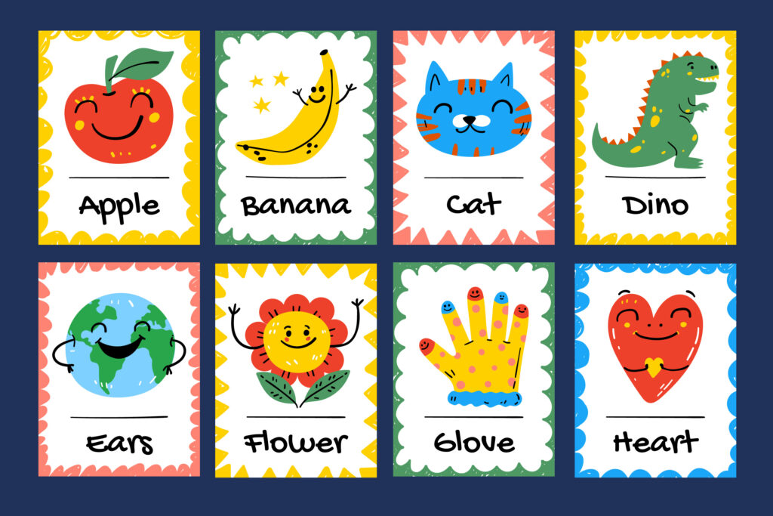

**A-Z Alphabet Flashcard**

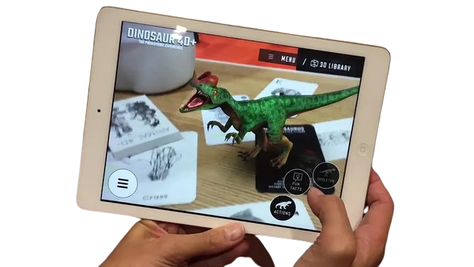

**Expected Benefit:**

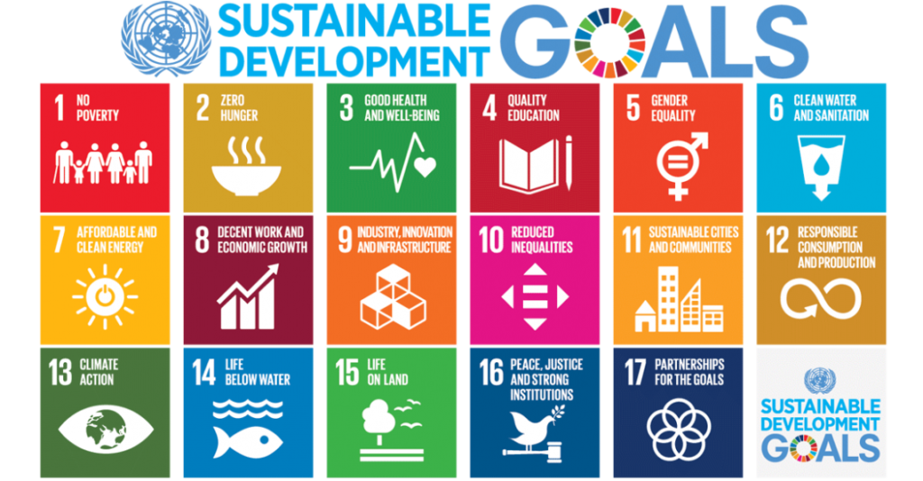

My project aligns with **United Nation’s SDG No.4 Quality education.**



This project proposes a solution by using **Augmented Reality (AR) technology** as a teaching aid to **revolutionize traditional teaching methods** and **upgrade the quality of education** for Myanmar children.

**Scope Management:**

**Project Scope Overview:**

The project aims to develop an Augmented Reality (AR) application for children's quality education, focusing on immersive learning experiences through interactive 3D models associated with alphabet flashcards. In this project, I will develop twenty six 3D models for A to Z alphabets flashcard. For example, when the user scans "A" alphabet with his mobile phone, my application will show "A for Airplane" augmented 3D models and the user can view this object in 360 degree, study how to pronounce in three languages-Burmese, English, Chinese. In total, the project will have 26 flashcard and their 26 three-dimensional augmented objects scene.

**Scope Objectives:**

1. Develop twenty-six 3D models representing objects corresponding to each alphabet from A to Z.

2. Create a user-friendly AR application interface for mobile devices, enabling seamless scanning of alphabet flashcards.

3. Implement interactive 3D scenes for each alphabet flashcard, providing users with a 360-degree view of augmented objects.

4. Integrate pronunciation guides in Burmese, English, and Chinese languages for each alphabet flashcard.

**Scope Implementation:**

- Development of twenty-six 3D models representing objects associated with each alphabet (A to Z).

- Design and implementation of a mobile AR application interface for scanning alphabet flashcards.

- Creation of interactive 3D scenes for each alphabet flashcard, allowing users to view objects from multiple angles.

- Integration of pronunciation guides in Burmese, English, and Chinese languages for each alphabet flashcard.

**Time Management:**

**Time Constraint**: The project must be completed within the specified timeline to align with academic deadlines and project milestones.

Project duration - **4 Months.**

**In first Month:** The project have 26 number of three-dimensional augmented models which will be developed by myself using Blender #D development software tool.

**In Second Month**: These 3D models are integrated and developed an application by writing codes using unity Application development engine. Add pronunciation feature and 360 degree viewing control.

**In Third Month:** Integrating all these components,the initial version of application will be released as a sample and make recursive testing.

**In Fourth Month:** The market for this application will be researched, and make market analysis, price analysis and competitor analysis. The feedback from customers will be asked for and make improvement.

**Cost Management:**

**Cost Management Report**

**Budget Allocation:**

The following budget allocation has been established for the project as a estimation:

1. Development Resources: $15,000

2. Software and Licenses: $5,000

3. Hardware and Devices: $3,000

4. Contingency Reserve (10% of Total Budget): $2,300

**Total Project Budget: $25,300**

**Cost Breakdown:**

**1. Development Resources:**

- Hiring developers and designers to create 3D models, develop the AR application, and integrate language features.

- Estimated Cost: $15,000

**2. Software and Licenses:**

- Purchase of software licenses for AR development tools, such as Unity and Vuforia Engine.

- Estimated Cost: $5,000

**3. Hardware and Devices:**

- Acquisition of mobile devices for testing and deployment of the AR application on iOS and Android platforms.

- Estimated Cost: $3,000

**4. Contingency Reserve:**

- Allocation of a contingency reserve to cover unexpected expenses or scope changes during the project.

- Estimated Cost: $2,300 (10% of Total Budget)

**Cost Management Strategies:**

**Resource Optimization**: Efficient utilization of development resources to maximize productivity and minimize costs.

**Vendor Negotiation**: Negotiation with vendors and suppliers to secure favorable pricing for software licenses and hardware purchases.

**Scope Control**: Strict adherence to the project scope to prevent scope creep and minimize additional costs.

**Budget Monitoring**: Regular monitoring of project expenditures to ensure alignment with the allocated budget and timely identification of any deviations.

**Quality Management:**

**Quality Objectives:**

**1. User Experience (UX):**

- Implement user-friendly navigation, interactive elements, and visually appealing design to enhance user satisfaction and engage user experience that is accessible to children of varying ages and backgrounds.

**2. Technical Performance:**

- Optimize rendering performance, minimize loading times, and ensure smooth performance of the AR application across different mobile devices and platforms

**3. Educational Effectiveness**:

- Ensure the educational content provided by the AR application is accurate, informative, and age-appropriate.

**Quality Management Processes:**

**1. Requirements Management:**

- Define clear and concise requirements for the AR application, including functional, technical, and educational requirements.

**2. Design Reviews:**

- Conduct regular design reviews to evaluate the usability, accessibility of the AR application interface.

**3. Testing and Quality Assurance:**

- Implement rigorous testing procedures to identify and address any bugs, errors, or inconsistencies in the AR application.

**4. Documentation and Training:**

- Maintain comprehensive documentation for the AR application, including user manuals, technical specifications, and educational materials.

Written by Mg Thwin Htoo Aung (6IST-1)

**University of Technology ( Yatanarpon Cyber City)**

**thwinhtoo469@gmail.com**